Simple Algorithm for withdrawing a sum of money from ATM

1. Inserting card to the ATM

2. Choosing preferred language

3. Selecting options

3.1 Checking balance

3.1.1 Show balance

3.2 Withdrawing money

3.2.1 Typing the amount

3.2.1.1 Checking typed amount greater or lesser than balance

3.2.2 Typing the password

3.2.2.1 Checking password

3.2.3 Asking for confirmation

3.2.4 ATM cash out the typed amount

4. Take money and card out of ATM

Area of Triangle

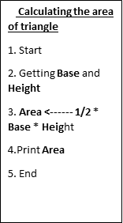

Perimeter of Triangle

Area of Square

Perimeter of Square

Area of rectangle

Perimeter of rectangle

Area of circle

Perimeter of circle